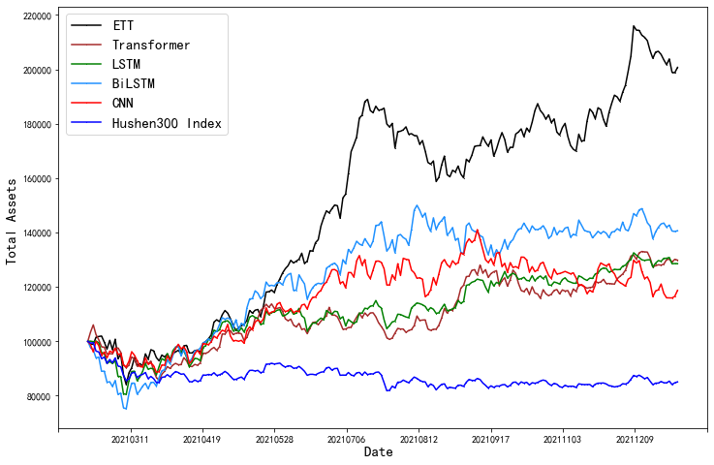

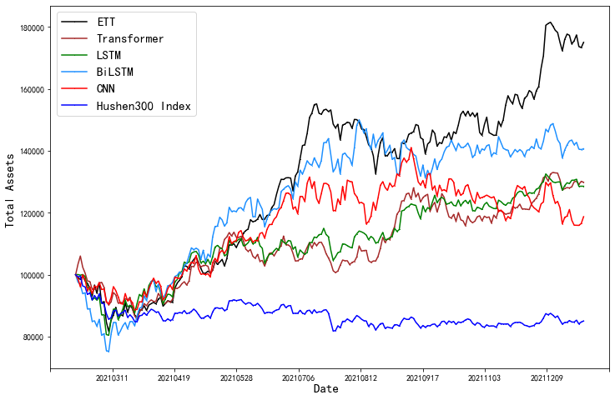

Droupout 0.1 batchsize 200 epoch30 lr 0.0001 Adam LayerNorm

|MSE:0.001002 |RMSE:0.031648 |MAE:0.023233

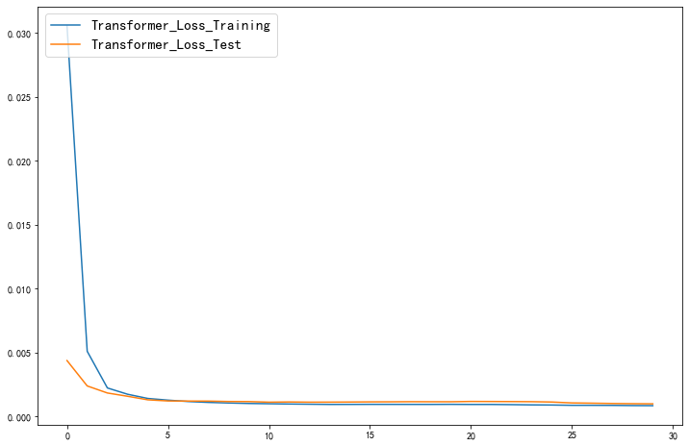

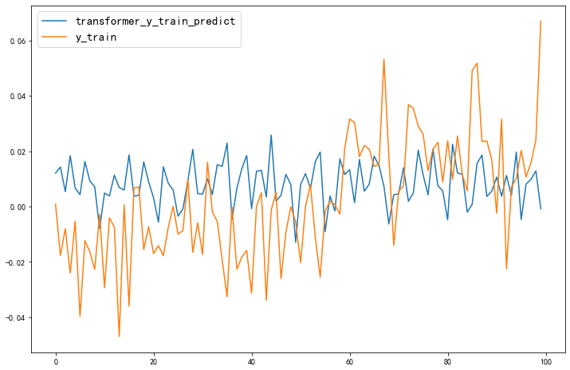

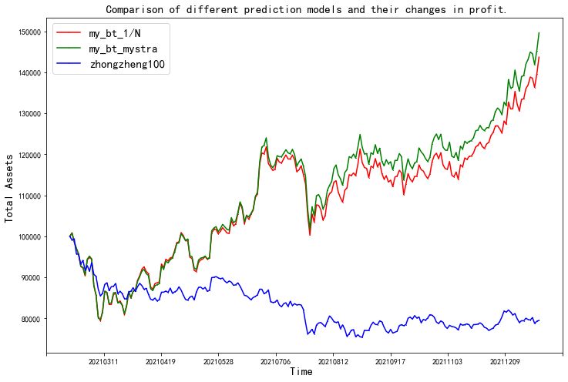

Droupout 0.1 batchsize 100 epoch30 lr 0.0001 Adam LayerNorm

|MSE:0.0010032 |RMSE:0.0316739 |MAE:0.0230876

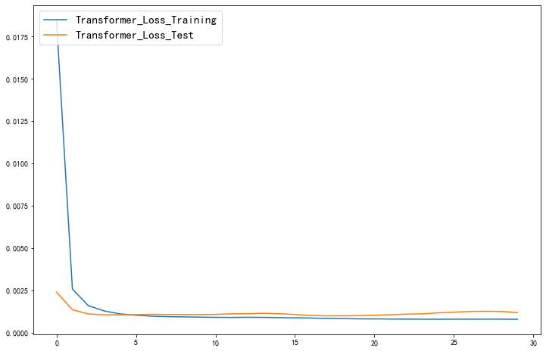

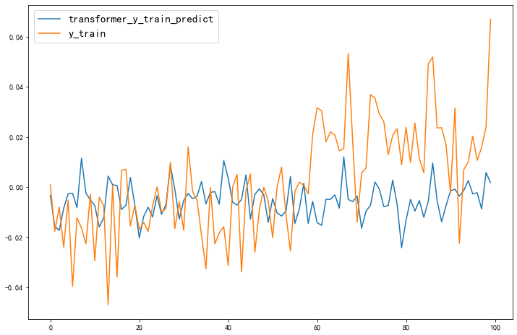

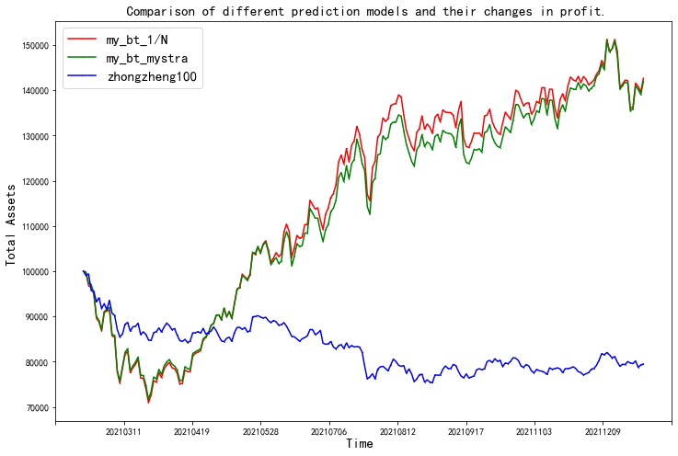

Droupout 0.1 batchsize 200 epoch30 lr 0.0001 Adam BatchNorm

MSE:0.0010016 |RMSE:0.0316481 |MAE:0.0232331

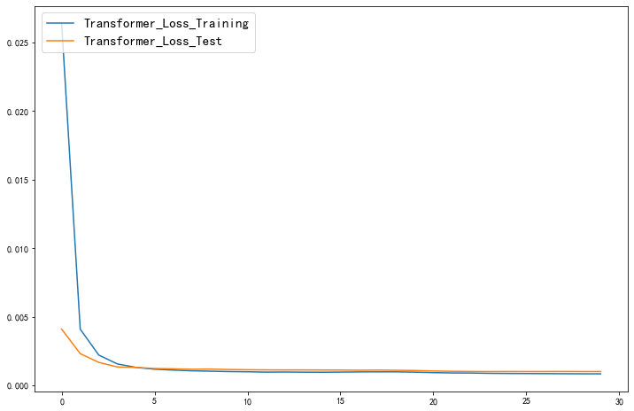

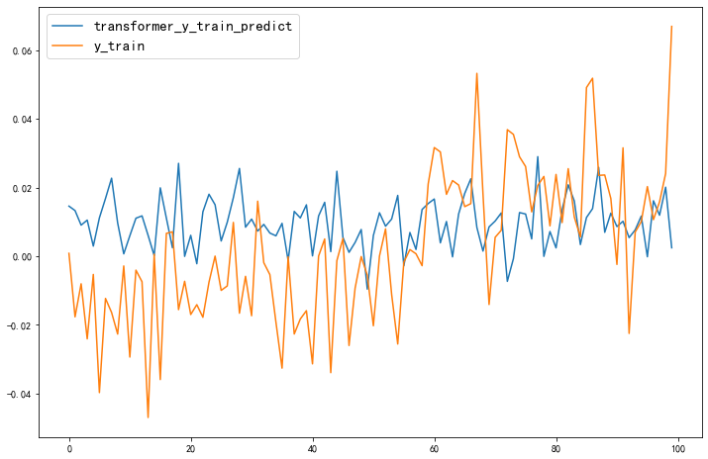

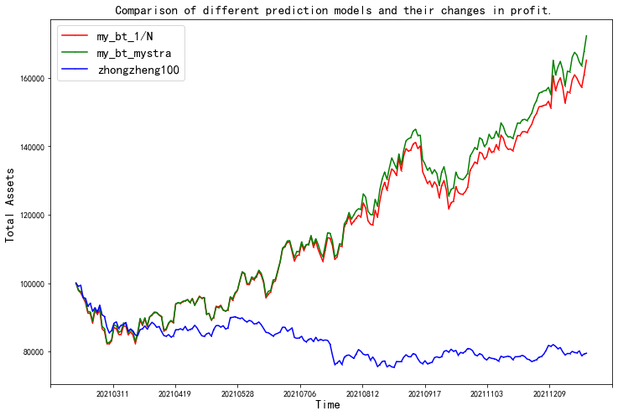

Droupout 0.1 batchsize 100 epoch30 lr 0.0001 Adam BatchNorm

|MSE:0.001045 |RMSE:0.032319 |MAE:0.023688

